Aejandro De La Torre
LIS 440
wk11: Pandas Subsetting and Statistics
11/18/25
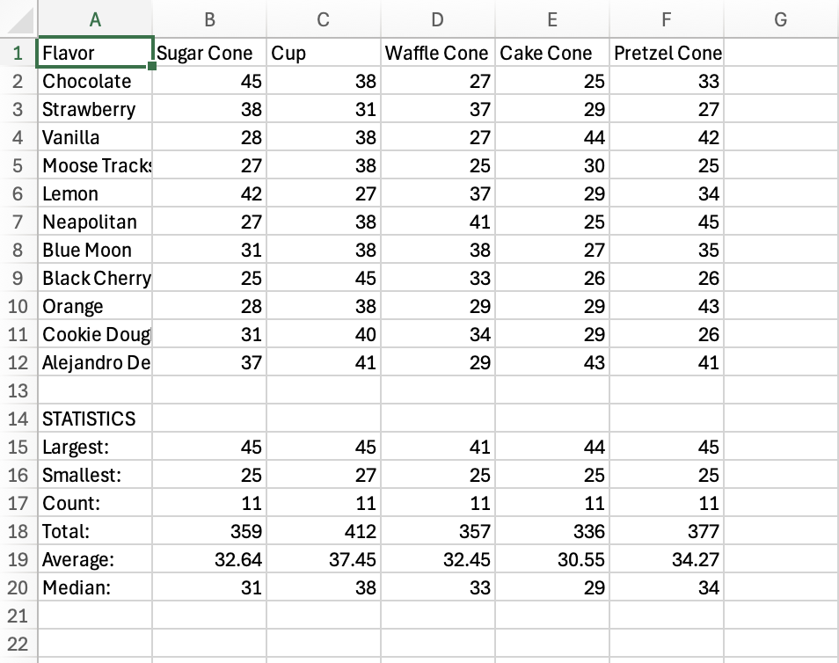

Code
# Import the necessary packages
import pandas as pd
import os
from pathlib import Path

# Print version of pandas
print("Alejandro De La Torre's code....")
print(pd.__version__)

# ----------------------------------------
# File & Path Setup
# ----------------------------------------

# Set root directory (two levels up from this script)
root = Path(__file__).parent.parent.resolve()

# Show current working directory
print("Current Working Directory:", Path.cwd())

# Define key directories
data = root / 'data'
data_raw = data / 'raw'
data_processed = data / 'processed'

# Fetch the data
ic_df = pd.read_csv(data_processed / 'icecream_random.csv')
print("\n:Random Ice Cream data:")
print(ic_df)

# --------------------------------------------------------
# Sugar Cone Stats
# --------------------------------------------------------
print("\nSugar Cone Sales:")
sugar = ic_df["Sugar Cone"]
print(sugar)

print("\nTotal Sugar Cone Sales:")
print(sugar.sum())

print("\nLargest Sugar Cone Sale:")
print(sugar.max())

print("\nSmallest Sugar Cone Sale:")
print(sugar.min())

print("\nNumber of Sugar Cone Sales Data Points:")
print(sugar.count())

print("\nMedian Sugar Cone Sales for All Flavors:")
print(sugar.median())

print("\nAverage Sugar Cone Sales for All Flavors:")
print(sugar.mean())

# --------------------------------------------------------
# Cup Stats
# --------------------------------------------------------
print("\nCup Sales:")
cup = ic_df["Cup"]
print(cup)

print("\nTotal Cup Sales:")
print(cup.sum())

print("\nLargest Cup Sale:")
print(cup.max())

print("\nSmallest Cup Sale:")
print(cup.min())

print("\nNumber of Cup Sales Data Points:")
print(cup.count())

print("\nMedian Cup Sales for All Flavors:")
print(cup.median())

print("\nAverage Cup Sales for All Flavors:")
print(cup.mean())

# --------------------------------------------------------
# Waffle Cone Stats
# --------------------------------------------------------
print("\nWaffle Cone Sales:")
waffle = ic_df["Waffle Cone"]
print(waffle)

print("\nTotal Waffle Cone Sales:")
print(waffle.sum())

print("\nLargest Waffle Cone Sale:")
print(waffle.max())

print("\nSmallest Waffle Cone Sale:")
print(waffle.min())

print("\nNumber of Waffle Cone Sales Data Points:")
print(waffle.count())

print("\nMedian Waffle Cone Sales for All Flavors:")
print(waffle.median())

print("\nAverage Waffle Cone Sales for All Flavors:")
print(waffle.mean())

# --------------------------------------------------------
# Cake Cone Stats
# --------------------------------------------------------
print("\nCake Cone Sales:")
cake = ic_df["Cake Cone"]
print(cake)

print("\nTotal Cake Cone Sales:")
print(cake.sum())

print("\nLargest Cake Cone Sale:")
print(cake.max())

print("\nSmallest Cake Cone Sale:")
print(cake.min())

print("\nNumber of Cake Cone Sales Data Points:")
print(cake.count())

print("\nMedian Cake Cone Sales for All Flavors:")
print(cake.median())

print("\nAverage Cake Cone Sales for All Flavors:")
print(cake.mean())

# --------------------------------------------------------
# Pretzel Cone Stats
# --------------------------------------------------------
print("\nPretzel Cone Sales:")
pretzel = ic_df["Pretzel Cone"]
print(pretzel)

print("\nTotal Pretzel Cone Sales:")
print(pretzel.sum())

print("\nLargest Pretzel Cone Sale:")
print(pretzel.max())

print("\nSmallest Pretzel Cone Sale:")
print(pretzel.min())

print("\nNumber of Pretzel Cone Sales Data Points:")
print(pretzel.count())

print("\nMedian Pretzel Cone Sales for All Flavors:")
print(pretzel.median())

print("\nAverage Pretzel Cone Sales for All Flavors:")
print(pretzel.mean())

Shell
>>> %Run ic_stats.py
Alejandro De La Torre's code....
2.3.3
Current Working Directory: /Users/alexdelatorre/Library/CloudStorage/OneDrive-UW-Madison/Coursework/L I S 440/Lectures/Week 11/wk11 Pandas Subsetting and Statistics/code

:Random Ice Cream data:
Flavor Sugar Cone ... Cake Cone Pretzel Cone
0 Chocolate 45 ... 25 33
1 Strawberry 38 ... 29 27
2 Vanilla 28 ... 44 42
3 Moose Tracks 27 ... 30 25
4 Lemon 42 ... 29 34
5 Neapolitan 27 ... 25 45
6 Blue Moon 31 ... 27 35
7 Black Cherry 25 ... 26 26
8 Orange 28 ... 29 43
9 Cookie Dough 31 ... 29 26
10 Alejandro De La Torre's Favorite 37 ... 43 41

[11 rows x 6 columns]

Sugar Cone Sales:
0 45
1 38
2 28
3 27
4 42
5 27
6 31
7 25
8 28
9 31
10 37
Name: Sugar Cone, dtype: int64

Total Sugar Cone Sales:
359

Largest Sugar Cone Sale:
45

Smallest Sugar Cone Sale:
25

Number of Sugar Cone Sales Data Points:
11

Median Sugar Cone Sales for All Flavors:
31.0

Average Sugar Cone Sales for All Flavors:
32.63636363636363

Cup Sales:
0 38
1 31
2 38
3 38
4 27
5 38
6 38
7 45
8 38
9 40
10 41
Name: Cup, dtype: int64

Total Cup Sales:
412

Largest Cup Sale:
45

Smallest Cup Sale:
27

Number of Cup Sales Data Points:
11

Median Cup Sales for All Flavors:
38.0

Average Cup Sales for All Flavors:
37.45454545454545

Waffle Cone Sales:
0 27
1 37
2 27
3 25
4 37
5 41
6 38
7 33
8 29
9 34
10 29
Name: Waffle Cone, dtype: int64

Total Waffle Cone Sales:
357

Largest Waffle Cone Sale:
41

Smallest Waffle Cone Sale:
25

Number of Waffle Cone Sales Data Points:
11

Median Waffle Cone Sales for All Flavors:
33.0

Average Waffle Cone Sales for All Flavors:
32.45454545454545

Cake Cone Sales:
0 25
1 29
2 44
3 30
4 29
5 25
6 27
7 26
8 29
9 29
10 43
Name: Cake Cone, dtype: int64

Total Cake Cone Sales:
336

Largest Cake Cone Sale:
44

Smallest Cake Cone Sale:
25

Number of Cake Cone Sales Data Points:
11

Median Cake Cone Sales for All Flavors:
29.0

Average Cake Cone Sales for All Flavors:
30.545454545454547

Pretzel Cone Sales:
0 33
1 27
2 42
3 25
4 34
5 45
6 35
7 26
8 43
9 26
10 41
Name: Pretzel Cone, dtype: int64

Total Pretzel Cone Sales:
377

Largest Pretzel Cone Sale:
45

Smallest Pretzel Cone Sale:
25

Number of Pretzel Cone Sales Data Points:
11

Median Pretzel Cone Sales for All Flavors:
34.0

Average Pretzel Cone Sales for All Flavors:
34.27272727272727
>>>

